The California ISO intermittently adjusts the Regional Access Charge Rate and Local Access Charge Rate with the effective date of any revised PTO’s TRR. At a minimum, the Regional Access Charge and Local Access Charge rates are adjusted annually on January 1 with the PTOs’ Transmission Revenue Balancing Account adjustments (TRBAA) as specified in specified in Sections 6 and 8 of Appendix F, Schedule 3 and Section 26 of the CAISO.

The TRBAA is provided to the CAISO along with the Transmission base TRR to develop the appropriate charges under the CAISO Tariff.

The following procedure provides the required steps for providing the TRBAA and the TRR to the CAISO for incorporation into the CAISO Transmission Access Charge Rates.

## Step 1: Prepare TAC Rates Spreadsheet

1. Download the latest version of the TAC Rates Calculation Template from <http://www.caiso.com/market/Pages/Settlements/Default.aspx> under Market, RC West and Administrative charges, Transmission access charge rates.
2. Open the Transmission Access Charge Rates Submission template file and fill in the application field(s).



* PTOs: PTOs ID
* TRR Effective Date: Effective date of Transmission Revenue Requirement
* TRR Docket #: FERC assigned Docket #
* TRBAA Effective Date: Effective date of Transmission Revenue Balancing Account Adjustment
* TRBAA Docket #: FERC assigned Docket #
* Total (High Voltage) HV Filed TRR – This information is generally located in Appendix of the FERC filing.
  + Base TRR: HV TRR from FERC filing
  + TRBAA: HV TRBAA from FERC filing
  + Standby Credit: HV Standby Credit from FERC Filing
  + Total: Value will be calculated from the HV inputs above
  + Gross Load: HV Gross Load from FERC Filing
* Total Low Voltage (LV) Filed TRR – This information is generally located in Appendix of the FERC filing.
  + Base TRR: LV TRR from FERC filing
  + TRBAA: LV TRBAA from FERC filing
  + Standby Credit: LV Standby Credit from FERC Filing
  + Total: Value will be calculated from the LV inputs above
  + Gross Load: LV Gross Load from FERC Filing
* Combined TRR
  + Value will be derived from the HV and LV inputs provided

1. Hit Save.

## Step 2: Submitting the template and FERC filing to the California ISO.

The completed template and the relevant FERC Filing and/or Order will need to be submitted to the CAISO for processing. There are two methods available for submitting this data to the CAISO. The methods are as follows:

**CIDI User(s):**

Create a new “Inquiry ticket” in Customer Inquiry Dispute and Information (CIDI) application. PTOs that have access to the CIDI application will need to use this method to submit the completed template and relevant FERC Filing and/or FERC Order to the ISO.

The steps are as follows:

1. Log into CIDI via the Market Participant Portal: <https://mpp.caiso.com/Pages/Default.aspx>
2. Follow the instructions on “How to create a new “Inquiry Ticket” case on the CIDI User Guide located at <http://www.caiso.com/Documents/NewCustomerInquiry_DisputeandInformation_CIDI_UserGuide.pdf>
3. In the CIDI ticket,

* Include the following phrase in the Subject of this Inquiry: “TAC Rate Adjustment Request”
* After the ticket has been created, attach/upload the completed template and the relevant FERC Filing and/or FERC order.
* The ticket will be routed to the appropriate group for processing. If there are any questions regarding the submittal, the Settlements Team will contact the PTOs directly.

**Non-CIDI User(s):**

PTOs that do not have access to the CIDI application will need to use this method to submit the completed template and relevant FERC Filing and/or FERC Order to the ISO.

1. Submit an email to Service Desk at [servicedesk@caiso.com](mailto:servicedesk@caiso.com).
2. In the email subject line, please include these specific phrase, “TAC Rate Adjustment Request”.
3. In the body of the email, please include this verbiage below for the Service Desk:

Service Desk, please create a ticket for the following request:

* + Insert this phrase in the CIDI subject line, “TAC Rate Adjustment Request”.
  + Attach the respective forms into the CIDI case (completed template and relevant FERC Filing and/or FERC order).

Once this email is submitted, it will be routed to the appropriate group for processing. If there are any questions regarding the submittal, the Settlements Team will contact the PTOs directly.

## Step 3: Processing timeline

Effective 01/01/2021, updated rates will be processed according to the following schedule:

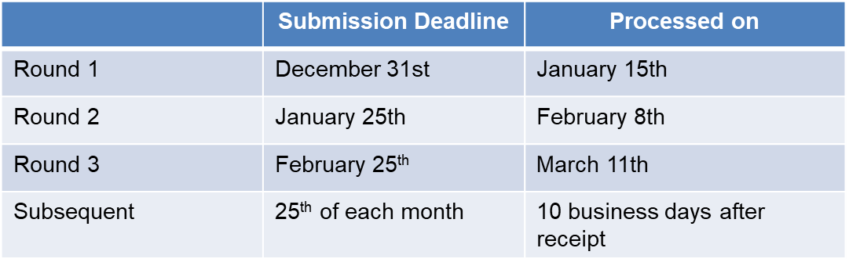

* + Submission deadline
    - PTOs can submit at any time
    - Will be logged and saved for processing once per month
  + 10 business day processing window
    - allows for flexibility in task planning
    - Provides predictable schedule for PTOs

## Step 4: Communication of Rate Changes

When a new rate is implemented, the CAISO will notify sent out a Market Notice and provide the details for the rate changes. This Market Notice is available on [www.caiso.com](http://www.caiso.com) under the Stay Informed >> Daily Briefing. PTOs may also subscribe to receive the Daily Briefing via email by clicking on the “Subscribe to the Daily Briefing” button on the Daily Briefing page. The direct link to the subscription page is <http://www.caiso.com/dailybriefing/Pages/default.aspx>.