Business Practice Manual for
Demand Response

Version 3

Date: April 1, 2020

Approval History
Approval Date: July 25, 2019
Effective Date: November 13, 2019
BPM Owner: Heather Kelley
BPM Owner’s Title: Director, Market Services
Revision History

Version | PRR No. | Date Posted | Revisions Effective | Description
3 | 1226 | April 1, 2020 | April 1, 2020 | PRR 1226: Appendix B updates to clarify TMNT measurement type data requirement.
2 | 1209 |  | November 13, 2019 | PRR 1209: Demand Response BPM, Emergency PRR, Appendix B table updates to include meter generation output and footnotes to the measurement types, load, and meter before meter after (MBMA)
1 | 1174 | July 30, 2019 | November 13, 2019 | Original BPM
TABLE OF CONTENTS
1. Introduction 1
1.1 Purpose of ISO Business Practice Manuals 1
1.2 Purpose of this Business Practice Manual 1
1.3 References 2
2. Proxy Demand Resources (PDR) and Reliability Demand Response Resources (RDRR) Demand Response Participation Models 3
2.1 Product Overview 3
2.2 Process Overview 10
2.3 Market Participation Demand Response Registration Checklist 11
2.4 Executing a Demand Response Provider Agreement (DRPA) 13
2.5 Obtaining a Demand Response Provider (DRP) ID 14
2.6 Use of a Certified Scheduling Coordinator 14
3. Load Serving Entities (LSE) and Utility Distribution Companies (UDC) 14
3.1 Obtaining a Load Serving Entity (LSE) ID or Utility Distribution Company (UDC) ID 15
4. Demand Response Registration System (DRRS) 15
5. Performance Evaluation Methodology Approval Process 16
5.1 Metering Generator Output 17
5.2 Metering Generator Output with Customer Load Baseline 21
5.3 Control Group 22
5.4 Day Matching (5-in-10 Residential Only, 10-in-10, and Combined) 23
5.5 Weather Matching 27
6. Approved Statistical Sampling Methodology 28
7. Resource Registration 33
8. Generation Data Template Submission and Processing 33
9. Net Qualifying Capacity (NQC) values for Resource Adequacy (RA) 37
10. Telemetry 37
11. Using the Appropriate Systems for Meter Data Management, and Performance Data Submittal 37
12. Using Customer Market Results Interface (CMRI) 38
13. DRRS Monitoring Process 38
14. Outages 39
15. Net Benefits Test (NBT) 39
Appendix A: Definitions 41
Appendix B: Baseline/Performance Evaluation Methodology Data Submittal Requirements 44

Attachments:

List of Exhibits:

Introduction
Welcome to the ISO BPM for Demand Response. In this Introduction you will find the following information:
- The purpose of ISO BPMs
- What you can expect from this ISO BPM
- Other ISO BPMs or documents that provide related or additional information

Purpose of ISO Business Practice Manuals
The Business Practice Manuals (BPMs) developed by ISO are intended to contain implementation detail, consistent with and supported by the ISO Tariff, including: instructions, rules, procedures, examples, and guidelines for the administration, operation, planning, and accounting requirements of ISO and the markets. Each Business Practice Manual is posted in the BPM Library at: http://bpmcm.ISO.com/Pages/BPMLibrary.aspx

Purpose of this Business Practice Manual
The BPM for Demand Response covers the responsibilities for the CAISO, Scheduling Coordinator (SC), Demand Response Provider (DRP), and processes associated with ISO Tariff provisions related to Demand Response. The BPM is intended for those entities that expect to participate in the ISO Markets.
The provisions of this BPM are intended to be consistent with the ISO Tariff. If the provisions of this BPM nevertheless conflict with the ISO Tariff, the ISO is bound to operate in accordance with the ISO Tariff. Any provision of the ISO Tariff that may have been summarized or repeated in this BPM is only to aid understanding. Even though every effort will be made by the ISO to update the information contained in this BPM and to notify Market Participants of changes, it is the responsibility of each Market Participant to ensure that he or she is using the most recent version of this BPM and to comply with all applicable provisions of the ISO Tariff.
A reference in this BPM to the ISO Tariff, a given agreement, any other BPM or instrument, is intended to refer to the ISO Tariff, that agreement, BPM or instrument as modified, amended, supplemented or restated.
The captions and headings in this BPM are intended solely to facilitate reference and not to have any bearing on the meaning of any of the terms and conditions of this BPM.

References
The definition of acronyms and words beginning with capitalized letters are given in the BPM for Definitions & Acronyms.
Other reference information related to this BPM includes:
- The BPM for Metering
- The BPM for Reliability Requirements
- The BPM for Market Instruments
- The BPM for Market Operations
- The BPM for Direct Telemetry
- The BPM for Settlements and Billing
- ISO Tariff

Proxy Demand Resources (PDR) and Reliability Demand Response Resources (RDRR) Demand Response Participation Models
In this section, you will find the following information:
- An introduction to Proxy Demand Resources (PDR) and Reliability Demand Response Resources (RDRR) in addition to their descriptions.
- An overview of their associated business processes including:
- The Demand Response Provider Agreement and its process
- The Demand Response Registrations System (DRRS) and a description of the resources registration process
- A description of post market Meter Data development, submittal, baseline and performance measurement (Demand Response Energy Measurement)
- A description of the monitoring metrics in place for these resources
- A description of their participation requirements

Product Overview
CAISO introduced two products that rely on the same technical functionality and infrastructure:

- Proxy Demand Resource (PDR)
- Reliability Demand Response Resource (RDRR)

The CAISO developed the Proxy Demand Resource (PDR) product to increase demand response participation in the ISO’s wholesale Energy and Ancillary Services markets. Additionally, PDR will help in facilitating the participation of existing retail demand response into these markets.
The CAISO developed the Reliability Demand Response Resource (RDRR) product to further increase demand response participation in the ISO markets by facilitating the integration of existing emergency-triggered retail demand response programs and newly configured demand response resources that have reliability triggers and desire to be dispatched only under certain system conditions.
In addition, RDRR enables the integration of CPUC-jurisdictional emergency responsive demand response resource programs. RDRRs can economically bid and be dispatched in the day-ahead market but only be dispatched for reliability in the real-time market. RDRRs cannot offer or self-provide Ancillary Services or submit RUC availability bids. The RDRR bid option is set at 5 minute and RDRRs are not eligible to change the bid dispatchable option to a 60 or 15 minute. RDRR participation is limited to CPUC-jurisdiction programs and capped by the amount of MWs that count for Resource Adequacy (RA) based on a CPUC settlement agreement.
PDR and RDRR products each provide the capability for an aggregator of retail customers, working with a certified CAISO Demand Response Provider (and SC), to bid demand response on their behalf directly into the ISO’s organized markets to the extent permitted by applicable laws and regulations regarding retail customers
In general, a PDR or RDRR is a combination of Load scheduled by a Load Serving Entity at the Default LAP and a Bid to curtail submitted by the Demand Response Provider (DRP) using a separate proxy generator with a distinct Resource ID. The LSE and the DRP may be the same or different entities.
A PDR or RDRR will be treated in the markets as a proxy generator bid as an aggregate generator, which may be defined at a single node or across multiple nodes within a CAISO defined Sub-LAP. The scheduling, dispatch, and settlement of the PDR or RDRR will be as a proxy generator resource as a distinct Resource ID. The LSE base Load will be scheduled and settled at the Default LAP (DLAP). Settlements for energy provided by PDRs and RDRRs shall be based on the Demand Response Energy Measurement which is calculated using an approved Performance Evaluation Methodology (see CAISO Tariff Sections 4.13.4 and section 5 of this BPM. The Demand Response Energy Measurement applicable to use of the Performance Evaluation Methodology is the resulting Energy quantity calculated by comparing the Customer Baseline of a PDR or RDRR against its actual underlying Load for a Demand Response Event. A PDR or RDRR with separately measured behind the meter generation, utilize Meter Data consisting of its total gross consumption when using the Customer Load Baseline Methodology. The Demand Response Energy Measurement for a PDR or RDRR using the MGO methodology consisting of registered behind-the-meter generation is the quantity of Energy equal to the difference between (i) the Energy output, and (ii) the Generator Output Baseline for the behind-the-meter generation registered in the PDR or RDRR, which derives from the Energy output of the behind-the-meter generation only, independent of offsetting facility Demand. For a PDR or RDRR using the combination of both methodologies, the Demand Response Energy Measurement will be their independently derived Demand Response Energy Measurements’ resulting sum.

The Demand Response Energy Measurement for the PDR or RDRR, representing the curtailed or MGO offsetting portion of the resource’s Load, is settled directly with the DRP’s SC.
The following summarizes the Proxy Demand Resource or Reliability Demand Response Resource product design attributes:
- A DRP may participate in the CAISO Markets separately from the LSE;
- The LSE and Utility Distribution Company (UDC) have the opportunity to review location information for a registration requested by a DRP;
- A PDR is eligible to participate in the Day-Ahead Energy market, Real-Time Energy market and Ancillary Services market to provide Spinning and Non-Spinning Reserves;
- A RDRR is eligible to participate in the Day Ahead Energy market and Real-Time Energy market;
- PDR and RDRR are load curtailment products. Performance for the resource will be measured in aggregate based on individual location load curtailment only and must not include measured export of energy from any of these individual locations;
- The CAISO does not prohibit net-energy metered (NEM) locations from participating in PDRs or RDRRs, however, meter data from NEM locations must only represent load or the resulting load offset when using the MGO methodology;
- Meter data intervals in which there is a net export of energy, at any underlying PDR or RDRR location, must be set to zero (0) when using a Customer Load Baseline methodology. This must be performed prior to summing individual location meter data in the development of the aggregated SQMD to the CAISO for that PDR or RDRR resource. Meter Data will consist of Energy output of the behind-the-meter generation up to, but not including, output that represents an export of energy from that location. Additionally, when calculating the Generator Output Baseline using the MGO methodology, meter data must a) be set to zero in any Settlement interval in which the behind-the-meter generation is charging and b) consist of the Energy output of the behind-the-meter generation up to, but not including, output greater than its facility Demand.
- The DRP’s SC submits a PDR or RDRR bid to curtail Load and receive Automated Dispatch System (ADS) instructions as if it were a generator. The PDR or RDRR is bid and settled at a PNode (which could be a specific location or an aggregation of PNodes, and Settlement occurs directly between the CAISO and the DRP’s Scheduling Coordinator;
- The LSE continues to forecast and schedule its total Load at the Default LAP;
- PDRs and RDRRs consists of:
  - Residential End Users: DRP may elect to use either the ten-in-ten, metering generator methodology, control group methodology, five-in-ten methodology, or weather matching methodology.
  - Non-residential End Users: DRP may elect to use either the ten-in-ten, metering generator methodology, control group methodology, or weather matching methodology.
The following methodologies may be utilized to calculate Customer Load Baselines and Demand Response Energy Measurements for PDRs and RDRRS:
- Performance of the PDR or RDRR using a Ten in Ten Methodology is generally determined through a pre-determined baseline calculation using the last 10 non-event days with a look back window of 45 days and a bidirectional adjustment capped at 20%. PDR or RDRR using behind-the-meter generation to offset Demand may submit for use, in the Ten in Ten Methodology, Meter Data reflecting the total gross consumption, independent of any offsetting Energy produced by separately metered behind-the-meter generation.
- Performance of the PDR or RDRR using a Five in Ten Methodology is generally determined through a pre-determined baseline calculation using the last 5 non-event days with a look back window of 45 days and a bidirectional adjustment capped at 1.4 (71% to 140%). PDR or RDRR using behind-the-meter generation to offset Demand may submit for use, in the Five in Ten Methodology, Meter Data reflecting the total gross consumption, independent of any offsetting Energy produced by separately metered behind-the-meter generation.
- Performance of the PDR or RDRR using a Meter Generator Output methodology consisting of registered behind-the-meter generation is the difference between the measured Energy output of the behind-the-meter generation and its calculated Generator Output Baseline which is generally determined through a pre-established baseline calculation using the last 10 similar non-event hours with a look back window of 45 days.
PDR or RDRR using Meter Generator Output may separately calculate baselines for gross load not including behind-the-meter generation with approved customer load baseline such as either Five in Ten or Ten in Ten methodologies depending on the customer classes. These two baselines are to be used independently to establish separate performance for the customer load and the behind-the-meter generation. Total performance is the sum of the Meter Generator Output and the customer load baseline performances.
PDR or RDRR composed of both residential and nonresidential customers may choose to calculate separate baselines for the different customer classes. Total performance is the sum of the Ten in Ten and Five in Ten performances.
- Performance of the PDR or RDRR using a Control Group Methodology will identify a control group that must consist of 150 distinct End Users (or more), that are registered in the Demand Response System and that do not respond to CAISO dispatch. The control group must have nearly identical demand patterns and be geographically similar such that they experience the same weather patterns and grid conditions as the PDR and RDRRs that respond to the dispatch (Treatment Group). The control group’s aggregate Demand during the same Trade Date and Trade Hour as the Demand Response Event, divided by the relevant number of End Users will define the baseline.
- Performance of the PDR or RDRR using a Weather Matching Methodology is generally determined by development of a baseline using the four (4) days, from a pool of non-event days, with the closest daily maximum temperature to the day in which the event occurred. Begin by collecting meter data for ninety (90) calendar days prior to the event day, working sequentially backwards from the Trading Day under examination, including only business days if the Trading Day is a business day, including only non-business days if the Trading Day is a non-business day, and excluding calendar days on which the Proxy Demand Resource was subject to an Outage or previously provided Demand Response Services (other than capacity awarded for AS or RUC) or the Reliability Demand Response Resource was subject to an Outage as described in Section 12.10 of this BPM, or previously provided Demand Response Services. The weather matching methodology has a bidirectional adjustment capped at 1.4 (71% to 140%).
- The CAISO tariff provision to statistically derive meter data was included to accommodate participation of an aggregated PDR/RDRR comprising several locations, some of which are interval metered and have revenue quality meter data available, and with the condition that the balance of locations would mimic the metered random sample. Once the randomly sampled fraction of revenue quality meter data is converted to settlement quality meter data (SQMD), the sum is then scaled to derive and submit the SQMD sized for the PDR or RDRR. This scaled SQMD value is called the “virtual” SQMD. The calculation detail for this virtual SQMD can be found in the Demand Response User Guide.
Virtual SQMD derived based on statistically sampled physical metering rather than physical metering data for all locations, is treated identical to any other SQMD. Virtual SQMD can only be used for a PDR or RDRR selecting the Customer Load Baseline Performance Methodology. Market participants providing statistically sampled SQMD may be requested to comply with ISO information requests to audit their meter data collection and “virtual” meter data scaling process.
A Demand Response Provider representing a PDR or RDRR may submit a written application to the CAISO for approval of a methodology to statistically derive meter data for the PDR or RDRR that consists of a statistical sampling of Energy usage data. (CAISO Tariff Section 10.1.7). The CAISO will accept, as pre-approved, any application requesting use of the methodology detailed in the Demand Response User Guide for the following cases:
- For day-ahead energy participation only, when hourly interval metering is not installed at all underlying resource locations. Not applicable for ancillary service participation.
- For day-ahead energy participation only, when hourly interval metering is installed at all underlying resource locations but RQMD is not derived using the hourly interval meter data for settlement purposes, but is developed using load profiles. Not applicable for ancillary service participation.
- For real-time and ancillary services participation when interval metering installed at all underlying resource locations is not recorded
To request to submit statistically derived data to the CAISO, the DRP can access the template on the CAISO website and submit the completed template to PDR@caiso.com. Upon receipt of the request, the CAISO has 10 business days to review the template for completeness, make additional inquiries and initiate the document for digital signature.
- The CAISO will adjust the Settlement of the PDR/RDRR associated Load Serving Entity LSE based on the measured performance of the PDR or RDRR only when the Real Time Market Clearing Price is below the threshold Market Clearing Price set forth in Section 30.6.3.1.
With the implementation of ESDER Phase 3A, several changes for PDRs and RDRRs will be instituted:
- New dispatchable bid options of 60 minutes or 15 minutes for PDR resources in addition to the existing 5 minute dispatchable bid option for the real-time market.
- Removal of the single LSE requirement and default load adjustment (DLA) for Demand Response registrations.
- Measurement type – “BASE” is added for compliant to the ISO Tariff section 11.6.1 with respect to ESDER 2. The BASE measurement type is for monitoring and auditing purposes only. The SCs must submit the calculated Customer Load Baseline (CLB) as defined in the tariff. Additional use of current measurement type, TMNT data submittal requirements has also been added for approved CAISO baselines. To facilitate this for the implementation of ESDER 3A, additional data requirements are outlined in Appendix B of this BPM.
The BPM for Demand Response addresses several of these design attributes; however, additional BPMs have changed to reflect PDR and RDRR design attributes. The following BPMs should be reviewed for further information not provided within this section of the BPM for Demand Response.
Ref# | BPM
1 | Metering
2 | Compliance Monitoring
3 | Definitions & Acronyms
4 | Direct Telemetry
5 | Managing Full Network Model
6 | Market Instruments
7 | Market Operations
8 | Outage Management
9 | Scheduling Coordinator Certification & Termination
10 | Settlements & Billing
11 | Reliability Requirements

A supplement document to the BPM for Demand Response document is the Demand Response System User Guide which provides in-depth information on the application, and automated systems that are in place to enable participation of Proxy Demand and Reliability Demand Resources. This document is located on the CAISO website at caiso.com. It is referenced throughout this section to highlight subject matter for which greater detail is available.

Process Overview
The following diagram is provided to illustrate the process and estimated timing of processes from registration through participation in the CAISO Markets into the CAISO’s post market processing, including metering, Settlements and compliance monitoring for PDR and RDRR. The following sections describe process steps and application impacts specific to PDR and RDRR market participation.
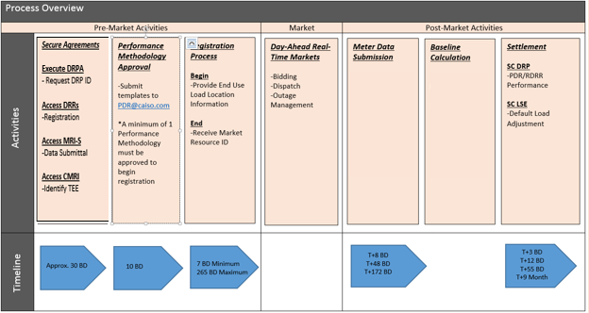

Creating and Registering Locations and Resource process flow
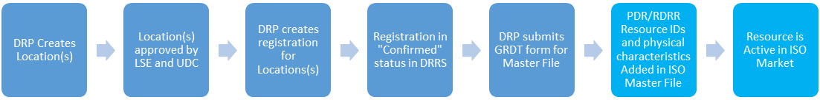

Market Participation Demand Response Registration Checklist

Information Request Sheet | Submitted | ◻
Executing a Demand Response Provider Agreement (DRPA) | Received for review  Executed – Signed/Returned | ◻  ◻
Demand Response Provider (DRP ID) assigned by ISO | Received | ◻
Scheduling Coordinator Assignment | Obtained | ◻
Demand Response System Access (DRRS) – Production and Map Stage (Market Simulation) environments | AIM request submitted (DRRS)  DRRS certificate received  DRRS access verified | ◻  ◻  ◻  ◻  ◻  ◻
DRRS/PDR/RDRR Training | User guide reviewed  Request training (DRRS)  Training completed (DRRS) | ◻  ◻  ◻
DRRS Automated Email Notification | Submitted Contacts to be added to the database | ◻
Market Results Interface - Settlements (MRI-S) | AIM request submitted (MRI-S) | ◻
Customer Interface for Resource Adequacy (CIRA) | Applicable to resources with resource adequacy (RA). | ◻
Performance Evaluation Methodology (PEM)/Baseline Methodology Form | Submitted | ◻
Master File (MF) | Submitted access request. Applicable to SC.  Note: Master File database contains static data that reflects the operational characteristics of resources that participate in the CAISO markets. SC for the resource may need to make changes to specific operating parameters. | ◻
Customer Market Results Interface (CMRI) | Submitted access request. Applicable to SC. | ◻

Executing a Demand Response Provider Agreement (DRPA)
To initiate a Demand Response Provider Agreement (DRPA), an information request sheet must be filled out completely and returned to Regulatory Contracts at regulatorycontracts@caiso.com. Once the information request sheet has been reviewed for completeness, it will be processed by contracts and a Demand Response Provider Agreement will be originated. The information request sheet for the DRPA can be obtained at www.caiso.com.
The pro forma Demand Response Provider Agreement is incorporated in Appendix B of the CAISO Tariff. This agreement must be signed by a DRP and the CAISO and provided prior to requesting a PDR or RDRR Resource ID. As with other CAISO agreements, the Demand Response Provider Agreement will bind the DRP to the CAISO Tariff. This agreement requires that the DRP use a certified Scheduling Coordinator (note, the SC must be certified to submit Settlement Quality Meter Data and have a Meter Service Agreement for Scheduling Coordinators with the CAISO) for all required tariff activities with the CAISO. The Demand Response Provider Agreement requires that the DRP have sufficient contractual relationships with the end use customers, LSE, and UDC and meet any Local Regulatory Authorities’ requirements prior to participating in the CAISO Markets. This agreement process will have a ten (10) Business Day turn-around timeframe. After the DRPA has been executed, the DRP shall submit a DRP ID request form to the CAISO at PDR@caiso.com. The DRP ID request form can be found on the CAISO webpage at: http://www.caiso.com/participate/Pages/Load/Default.aspx. If the request is approved, the CAISO will assign a new DRP ID.
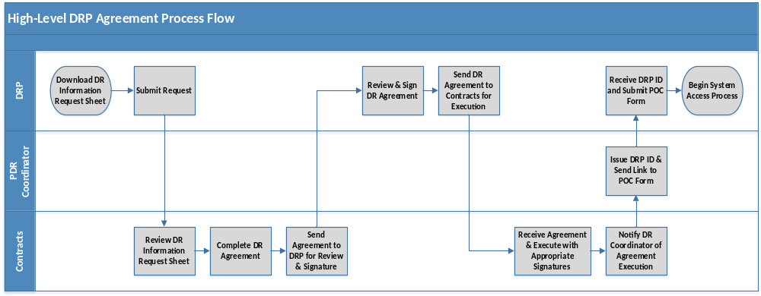

Obtaining a Demand Response Provider (DRP) ID
Once the Demand Response Provider Agreement (DRPA) has been executed, the following shall occur:
- DRP shall submit a DRP ID request form to CAISO at pdr@caiso.com. The DRP ID request form can be found at http://www.caiso.com/participate/Pages/Load/Default.aspx.

- After the DRP ID request form has been reviewed and approved, CAISO shall assign a new DRP ID. If the request is denied, CAISO will contact the requester to request for further information.

Use of a Certified Scheduling Coordinator
The CAISO requires the use of a certified Scheduling Coordinator to be eligible to transact business directly with the CAISO. A DRP could endeavor to become a certified Scheduling Coordinator or use an existing certified Scheduling Coordinator. It is important to note that the certification process for a new Scheduling Coordinator could take up to 120 days. A list of certified Scheduling Coordinators is maintained on the CAISO Website, under the reference tab of the operations center page. The DRP must enter into the appropriate contractual relationship with a certified Scheduling Coordinator and notify the CAISO of the Scheduling Coordinator it will be using; this can be done by a letter submitted to the attention of the CAISO’s “External Affairs” group. By using a certified Scheduling Coordinator, all requirements, as outlined in the BPM for Scheduling Coordinator Certification and Termination, will be maintained by the Scheduling Coordinator and the DRP would not have to satisfy these requirements (for example: system requirements, credit requirements, demonstration of market proficiency, emergency procedures, and establishing qualifications to submit Settlement Quality Meter Data) independently.

Load Serving Entities (LSE) and Utility Distribution Companies (UDC)

End use customer load served by an LSE and provided distribution services by a UDC may be represented in the wholesale market by a third party DRP. Therefore, the CAISO systematically facilitates a registration process during which these entities are informed of a DRP’s identification of their end-use customers, referenced by a unique service account number, and intent to use their load response capabilities as a PDR or RDRR. The LSE and UDC are identified when the locations are created by DRPs during the registration process, therefore, an LSE ID and UDC ID must be available. In addition, for the LSE and UDC to exercise their review capability, they must obtain a unique ID.
It is important for DRPs to work with the LSEs and UDCs for all the end-use customers they represent to ensure they have obtained their IDs from the CAISO prior to commencing with the PDR/RDRR registration process.

Obtaining a Load Serving Entity (LSE) ID or Utility Distribution Company (UDC) ID
The CAISO maintains a list of DRP, LSE, and UDC IDs that have been issued. This list is located at: http://www.caiso.com/Documents/ListofDemandResponseParticipants.pdf. California companies must be listed on either the CEC website as an Electric Load Serving Entity (LSE) or the CPUC website as an Electric Service Provider (ESP). Non-California companies must be designated by their local regulatory authorities as LSE/ESP equivalents.

- The LSE or UDC shall submit a request form to CAISO at pdr@caiso.com. These request form(s) can be found at: http://www.caiso.com/participate/Pages/Load/Default.aspx.

- After the request form has been reviewed and approved, the CAISO shall assign a new LSE ID or UDC ID. If the request is denied, the CAISO will contact the requester to request for further information.

Demand Response Registration System (DRRS)
The DRRS is accessed by the DRP to complete location, registration, and resource management processes in order to establish a PDR/RDRR resource ID for market participation. It is also accessed by the Load Serving Entity (LSE) and Utility Distribution Company (UDC) to manage their review process of locations submitted by the DRP.
The DRRS provides interfaces, both Application Program Interface (API) and User Interfaces (UI) to allow the DRP to create, modify, and remove location and to allow the LSE and UDC to review and provide comments on registered locations. The APIs allow for streamlined and automated
Proxy Demand Response (PDR) and Reliability Demand Response Resources (RDRR) location registration processing.
An additional functionality of the DRRS is to maintain a duplication check of locations being created by the DRP. The system performs this check to prevent duplicated overlapping effective dated locations from being created.
Please refer to the DR User Guide for more information about the DRRS UI, and the Technical Specifications for more information about the API.

Performance Evaluation Methodology Approval Process
DRPs must obtain approval for the use of any Performance Evaluation Methodology (PEM) before the DRRS will allow it to be a selectable option in the Registration Process. PEM requests will be received, reviewed, and approved by the CAISO. DRP can download the PEM templates and cover page from the CAISO website. Once approved, the CAISO will initiate the necessary DRRS updates so that it becomes an available registration option for that DRP ID. The approval is for the DRP’s use of that PEM for registration going forward. It is not a resource specific approval. PEM form request can be sent to PDR@caiso.com. DRPs will submit a completed template request to PDR@caiso.com. Upon receipt of request, the CAISO has 10 business days to review the PEM template. If the CAISO approves, it will make the necessary changes to the DRRS. As part of that process, the CAISO will initiate an approved PEM template for digital signature. The signed PEM template will not only serve as the CAISO’s acknowledgement of approval, but also will satisfy as a Settlement Quality Meter Data Plan, as outlined in Tariff Section 10.3.7.1. An email will be sent to the Scheduling Coordinator and DRP notifying them that the approved PEM is available for them to select in the DRRS. At this time, the DRP can begin the registration process. DRP/SC may update its Baseline Methodology only once every 30 days for a resource that has been used in a registration.
Pursuant to Section 4.13.4 of the tariff, the following PEMs will be available for request:
- Weather Matching
- Control Group
- Day Matching 10-in-10
- Day Matching 5-in-10 (residential only)
- Day Matching Combined
- Meter Generator Output
- Meter Generation Output with CLB (aka Meter Generation Output with 10-in-10)

The following Performance Evaluation Methodologies may be utilized to calculate the Customer Load Baselines and Demand Response Energy Measurements for PDR and RDRRs.
- Residential End Users may elect to use the ten-in-ten, metering generator output, control group, five-in-ten, or weather matching methodology.
- Non-residential End Users may elect to use the ten-in-ten, metering generator output, control group, or weather matching methodology.
For MGO performance methodology requires approval of metering device used. A SQMD Plan Template must be submitted for ISO approval. SQMD Plan template must be submitted To: NRI@caiso.com, and CC: PDR@caiso.com. The approval process may take up to 40 calendar days.
Additional documentation may be requested by the ISO. Please refer to the BPM for Metering for more information about SQMD.

Metering Generator Output
The Metering Generator Output (MGO) Methodology is a performance evaluation methodology in which the demand reduction value is based on the output of generator located behind the revenue meter for the demand resource. It requires a second meter, or “sub-meter” to isolate the output from any behind-the-meter generation. Under this metering configuration, the MGO methodology provides for the use of this meter to calculate a Demand Response Energy Measurement based upon the load curtailment provided by that behind-the-meter generator(s) only. The MGO Methodology utilizes a Generator Output Baseline calculation to determine load curtailment provided by the behind-the-meter generator during market participation that is in excess of what it generally provides to curtail facility load, namely, its generating baseline.
The following illustration reflects the metering configuration that includes a generation meter enabling the overall demand response at the location to be separated into a pure load (facility) response and a behind-the-meter generation device’s response or contribution.

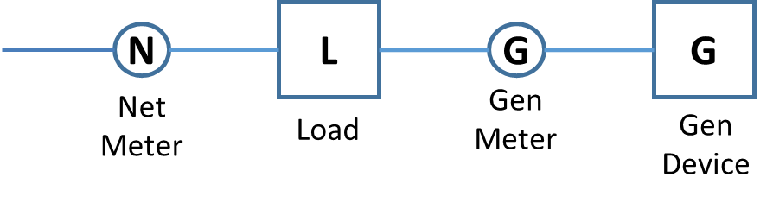
MGO is calculated by the DRP and not the CAISO. The SC for the DRP is responsible for ensuring that SQMD submitted to the MRI-S represents an accurate generation quantity for the resource which represents the Demand Response Energy Measurement calculated in compliance with the MGO Methodology per tariff sections 4.13.4.2 and 11.6.2.
This option would apply in instances where only the behind-the-meter device is registered in the PDR/RDRR (not the facility load as in the option available under the customer load baseline methodology). The demand response performance, referred to as DR_{SUPPLY}(t), is the demand reduction resulting from the output of the behind-the-meter generation device for dispatch interval t. The demand response performance DR_{SUPPLY}(t) would be evaluated based on the physical meter generator output G for dispatch interval t or G(t), adjusted by a quantity G_{LM} which represents an estimate of the typical energy output used for retail load modifying purposes and benefits. The calculated value, G_{LM}, would appropriately remove an estimated quantity of energy delivered by the device to the facility for its retail load modifying purposes, i.e. energy not produced in response to an ISO PDR/RDRR dispatch. The performance evaluation introduces an adjusted MGO value calculated by taking the difference between G(t) and G_{LM}, where the demand response performance attributed to a PDR/RDRR supply dispatch would be calculated as:
DR_{SUPPLY}(t) = – [G(t) – G_{LM}]

The adjustment for typical retail load modifying behavior, or G_{LM}, is established using a 10-in-10 non-event hour selection method on similar day types, i.e., comparing weekday events to weekday non-events, and weekend and holiday events to weekend and holiday4 non-events. An “event” is any ISO dispatch of a PDR/RDRR that occurs during an ISO Hour Ending interval, be it the full hour or a 5-minute interval in that hour. G_{LM} is calculated by looking back as far as 45 calendar days and calculating the simple average energy delivered during the 10 most recent non-event hours for the same day type and for the same event hour when the PDR/RDRR dispatch event occurred.

G_{LM} Calculation rules

Following are the rules to calculate G_{LM}:
- A 10-in-10 non-event hour selection method is used
  - The selection of non-event hours is performed by iterating backward up to 45 calendar days to find the target number of non-event hours for the same event hour and same day type beginning with the most recent days and calculating the simple average energy delivered by the device.
- The selection of Customer Baseline data will include a number of the most recent days, excluding different day-types and previous events hours within those days (definitions below)
- Two different day-types will be supported:
  - Weekday (Monday through Friday)
  - Weekend (Saturday, Sunday)
  - Holidays4
  - Weekend/HolidayError: Reference source not found (Saturday, Sunday, or any holidayError: Reference source not found)
- An event hour is any hour when there was an ISO market award or dispatch at or above the demand response net benefits test price threshold or outage recorded for the PDR or RDRR.
Market Participation | Status | Event Hour
DA award or RT dispatch ≥ NBT | yes | yes
AS Capacity Award only (PDR only) | yes | no
AS Energy Dispatch (PDR only) | yes | yes
RUC Capacity Award only | yes | no
Outage | yes | yes
  - Periods when the generating device meter is recording a load (charging) is not categorized as an event.

- Target & minimums are defined as:
 | Weekday | Weekend/HolidayError: Reference source not found
Target | 10 Hours | 4 Hours
Minimum | 5 Hours | 4 Hours

- Once the target number of hours is reached, selection ends and a simple average is calculated to determine GLM.
- If the target number of hours is not reached, but the minimum number of hours is reached, G_{LM} is calculated on the selected hours.
  - Example: If only 8 non-event hours for a week day for the applicable event- hour can be found across a 45-day look back, then those set of 8 non-event hours will be averaged.
- If the minimum number of hours is not reached, then GLM is set to zero.

Once the value for GLM is determined, the demand response performance, DR_{SUPPLY}(t), representing the demand response energy measurement would be calculated as:

DR_{SUPPLY}(t) = – [G(t) – G_{LM}]

Charging and Export Treatment

For hours when a behind-the-meter storage device is charging the scheduling coordinator metered entity should record a “zero” for those hours or intervals in that hour . For calculating G_{LM}, the ISO is only interested in the average energy output (not input) across the target or minimum number of hours required for that day type.
For intervals when a behind-the-meter generation results in the export of generation from the location, net meter N< 0 (see behind-the-meter generation meter configuration illustration above for reference), then the MWh amount settled in that interval is the MWh delivered up to N = 0. This net export check is done at each location level, not at the PDR/RDRR aggregate level. The ISO retains the authority to audit both the N and G meter data values submitted by the scheduling coordinator metered entity to ensure compliance with this net export rule.

Metering Generator Output with Customer Load Baseline
In cases where both the load and the behind-the-meter generation at a location respond to a market award or dispatch, the load curtailment provided would be the combined demand response performance attributed to both reduced load consumption by traditional load reduction methods and the behind-the-meter generation. The Demand Response Energy Measurement would combine calculated results using the Customer Load Baseline Methodology, using gross load meter data, and the MGO Methodology.
The combined CLB and MGO is calculated by the DRP. The SC for the DRP is responsible for ensuring that SQMD submitted to the MRI-S represents an accurate generation quantity for the resource which represents the combined Demand Response Energy Measurement calculated in compliance with both the CLB and MGO Methodologies per tariff section 4.13.14 and 11.6.3.
This option would apply in instances where both the load and the behind-the-meter device together are registered as the PDR/RDRR resource. Under this option, the demand response performance would be the combined demand response performance attributed to DR_{LOAD}(t) and DR_{SUPPLY}(t), as previously detailed under Customer Load Baseline and Metering Generator Output respectively, resulting in a total demand response reduction calculated as:
DR_{TOTAL}(t) = DR_{LOAD}(t) + DR_{SUPPLY}(t)

Or, DR_{TOTAL}(t) = B_{N-G}(t) – N(t) + G_{LM}(t)

Consider the following example where N(t) = 15, G(t) = - 7, B_{N-G}(t) = 25 and G_{LM}(t) = - 3. In this example, the total performance evaluation would be:

DR_{LOAD}(t) = B_{N-G}(t) – [N(t) – G(t)] = 3 and DR_{SUPPLY}(t) = – [G(t) – G_{LM}(t)] = 4

Or, DR_{TOTAL}(t) = 7

The net export rule must be applied to DR_{SUPPLY}(t) consistent with MGO. If N < 0, then the MWh amount settled in that interval is the MWh delivered up to N = 0. The ISO retains the authority to audit both the N and G meter data values submitted by the scheduling coordinator acting as the scheduling coordinator metered entity to ensure compliance against this net export rule.

Control Group
Pursuant to Section 4.13.4.3 of the tariff, control groups (CG) must consists of at least 150 distinct End Users that are geographically similar such that they experience the same patterns and grid conditions as the PDRs and RDRRs representing the Treatment group (TG). The Control group cannot combine/co-mingle Residential and Non-Residential to meet the requirement of 150 distinct End Users. The Service accounts (locations) representing the Control group and Treatment group will be identified in the DRRS. The Control group Locations will go through the normal LSE and UDC approval process. The difference between the Control group and the Treatment group is that during event days, the Treatment group experienced event dispatch while the Control group did not.
When creating Registration with the Control Group as the baseline method:
  - The Control Group Locations must have a minimum of 150 sample sizes, and can span across multiple subLAPs. The subLAP should be specified in the API request and cannot be “null”.
  - A valid DLAP can be submitted for the registration from the API. From the UI, the user is allowed to choose the DLAP from all the available DLAPs based on the subLAP selected.
  - In the XSD”, identify the valid values of “CG” (Control group location) and “TG” (Treatment group location) in the optional element “locationGroupType”. For the UI, the CG and TG must be identified.
  - A subLAP of all locations flagged as a TG must be the same. TG Locations subLAPs must also be the same as the registration.
  - The Registration must have a at least one TG location.
  - A TG location is not allowed to participate in a different registration with overlapping timeframe.
  - CG locations can participate in different CG baseline registration with overlapping timeframe if it is marked as a Control group location in the other registration as well.
The Control Group baseline methodology utilizes load data from two (2) distinct groups -- Control Group (CBL) load data and Treatment (TMNT) load data to develop Demand Response Energy Measurement (DREM).
- Control Group Load Data and Treatment Load Data
  - Where DREM = (hourly avg of control group load data) – (hourly avg of treatment group load data) x (#locations in treatment group) = {(total load of control group/# locations in control group) – (total load of treatment group/#locations in treatment group)} x #locations in treatment group

CBL and TMNT measurement types are used for monitoring and auditing purposes. The baseline load data should be submitted only if there is an event; the SC shall submit 90 days of historical data prior to the event day. This can be submitted on a daily basis or a full set once dispatch occurs.
Scheduling Coordinators are responsible for validating that the control group accurately represents the PDR/RDRR.
- For PDRs or RDRRs whose number of End Users have not changed for more than 10% in the prior month, the control group must be validated every other month.
- For PDRs and RDRRs whose number of End User have changed for more than 10% in the prior month, the control group must be validated monthly.
- A validation of the Meter Data for the PDR and RDRRs within the control group must be done by evaluating the previous 75 days, excluding the days where the resource performed. More specific criteria for this validation will be described within the Demand Response User Guide.

Day Matching (5-in-10 Residential Only, 10-in-10, and Combined)
Pursuant to sections 4.13.4.1 and 4.13.4.4 of the tariff, day matching baselines estimate what electricity use would have been in the absence of a Demand Response dispatch, using electricity use data on non-event, but similar days. The load patterns during a subset of non-event days are used to estimate the baseline for the event day. A total of 13 day matching baselines were evaluated to determine the most accurate and precise of the 13.There are differences between Residential and Non-Residential Day Matching. Non-Residential reflects current 10 in 10. Additionally, weekends are treated differently and reflected in both eligible days to consider then target days and minimums days required if targets cannot be met. Five-in-ten has a maximum adjustment factor of 1.4, the adjusted percentage can have a maximum value of one hundred-forty (140) percent to a minimum of seventy-one (71) percent. Ten-in-ten uses an adjusted percentage of a maximum value of one hundred-twenty (120) percent and a minimum value of eighty (80) percent.
In the case for Proxy Demand Response resources that combine residential and non-residential customers, the aggregate baselines for the two customer groups should be calculated separately using the appropriate baseline and then added together to represent the full resource. This is not necessary if the baseline method for both residential and non-residential customers is the same, as is the case for the current recommended weather matching baselines.
Also, eligible/targets/minimums should be used for day matching 5/10 and 10/10. Note: non-residential can may elect to use the 10-in-10 day matching. Residential can use either day-matching. Event is equivalent to Total Expected Energy (TEE) > 0.

Performance of the PDR or RDRR Residential or Non-Residential for 10 in 10 weekday event day treatment: ISO Tariff section 4.13.4.1
- Begin by collecting 45 days of historical data leading to the day of the event.
- Identify eligible days that occurred prior to the event, where TEE > 0 using the last ten (10) non-event weekdays, excluding HolidaysError: Reference source not found with a 45 day lookback.
- If the minimum number of days cannot be met, a minimum of five (5) calendar days will be used. If the target these targets cannot be met, please see refer to ISO Tariff section 4.13.4.1.a.
- Generate unadjusted baseline:
  - Unweighted: Simply averaged to generate the baseline
- Apply Adjustment percentage of a maximum value of one hundred-twenty (120) percent and a minimum value of eighty (80) percent.
  - For adjustment hours, please refer to ISO Tariff section 4.13.4.1c.
- Calculate the DREM by taking the difference between the baseline and the observed load, the data should have already been decomposed to the 5-minute increment level, and the load reductions relative the baseline are positive. The 5-minute interval should be set to 0 for settlements if baseline is less than the observed load.
Performance of the PDR or RDRR Residential or Non-Residential for 10 in 10 weekend event day treatment: ISO Tariff section 4.13.4.1
- Begin by collecting 45 days of historical data leading to the day of the event.
- Use the last four (4) calendar days including HolidaysError: Reference source not found
- Keep the last four (4) eligible calendar days.
- If the target cannot be met, please see refer to ISO Tariff section 4.13.4.1.a.
- Generate unadjusted baseline:
  - Unweighted: Simply averaged to generate the baseline
- Apply Adjustment an adjusted percentage of a maximum value of one hundred-twenty (120) percent and a minimum value of eighty (80) percent.
  - For adjustment hours, please refer to ISO Tariff section 4.13.4.1c.
- Calculate the DREM by taking the difference between the baseline and the observed load, the data should have already been decomposed to the 5-minute increment level, and the load reductions relative the baseline are positive. The 5-minute interval should be set to 0 for settlements if baseline is less than the observed load.
Performance of the PDR or RDRR Residential Only for 5 in 10 weekday event day treatment: ISO Tariff section 4.13.4.4
- Begin by collecting 45 days of historical data leading to the day of the event.
- Remove the ineligible days (weekends and HolidaysError: Reference source not found)
  - Average the hourly load for the eligible event hours for each day.
    - Example, if there was an event on 9/10/2015 at hour ending 17 to hour ending 19, then you would average hour ending 17 to hour ending 19 for each day.
- Sort by the average event load in decreasing order and select the highest 5 weekdays with the highest totalized load during the hours when the Demand Response Services were provided will be used.
- Generate unadjusted baseline:
  - Unweighted: Simply averaged to generate the baseline
- Calculate same-day adjustment.
  - Define the adjustment window periods. Adjustment hours are two hours immediately prior to the event period with a two hours buffer before and two hours after the event with a two hours buffer.
  - Average across those four (4) hours for both the baseline and the date the event was observed.
- Apply an adjustment percentage: adjustment percentage can have a maximum value of one hundred-forty (140) percent to a minimum of seventy-one (71) percent.
- Calculate the DREM by taking the difference between the baseline and the observed load, the data should have already been decomposed to the 5-minute increment level, and the load reductions relative the baseline are positive. The 5-minute interval should be set to 0 for settlements if baseline is less than the observed load.
Performance of the PDR or RDRR Residential Only for 5 in 10 weekend event day treatment: ISO Tariff section 4.13.4.4
- Begin by collecting 45 days of historical data leading to the day of the event.
- Remove the ineligible days; keeping only the eligible days: weekends, and holidaysError: Reference source not found, and days immediately prior to the event.
- Keep the last 5 eligible days. Sort by the average event load in decreasing order, and select the highest 3 eligible days with the highest totalized load during the hours when the Demand Response Services were provided will be used.
- Application of weights to baseline days
  - Weighted average. The closest day to the event day receives a weight of 50%, the next closest receives a weight of 30% and the furthest receives a weight of 20%.
Note: The closest in this case refers to days closest to the event day, not by the average event load sorting. The weighting is applied by multiplying the % for each day to the hourly load profiles, then summing. This is a weighted average.
- Calculate same-day adjustment.
  - Define the adjustment window periods. Adjustment hours are two hours immediately prior to the event period with a two hours buffer before and two hours after the event with a two hours buffer.
  - Average across those four (4) hours for both the baseline and the date the event was observed.
- Apply an adjustment percentage: adjustment percentage can have a maximum value of one hundred-forty (140) percent to a minimum of seventy-one (71) percent.
- Calculate the DREM by taking the difference between the baseline and the observed load, the data should have already been decomposed to the 5-minute increment level, and the load reductions relative the baseline are positive. The 5-minute interval should be set to 0 for settlements if baseline is less than the observed load.
Day Matching Combined allows the use of 5-in-10 to develop DREM for residential locations and 10-in-10 for non-residential locations (service accounts) when combined in the same resource.
Note: There may be requests to see DREM developed for each customer class if warranted.
The example below shows the combined residential and non-residential Day Matching.

Baseline Type Simplified Example
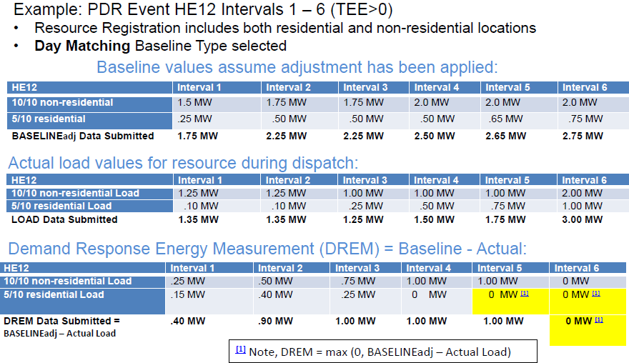

Weather Matching
ISO Tariff section 4.13.4.5

Pursuant to Section 4.13.4.5 of the tariff, weather matching baselines estimate what electricity use would have been in the absence of Demand Response dispatch during non-event days with similar weather conditions. The load patterns with the most similar weather conditions during a subset of non-event days are used to estimate the baseline for the event day. Weather matching baselines do not include information from an external control group. A total of seven weather-matching baselines were evaluated to determine the most accurate and precise of the seven.
Performance of DR using a Weather Matching Methodology is determined by:
- Using four days from a pool of non-event days, with the closest daily maximum temperature of event that occurred.
- Collecting 90 days of historical data leading to the day of the event. For weekdays, excluding the event days and HolidaysError: Reference source not found. For weekends and HolidaysError: Reference source not found, exclude event days.
- Adjustment hours are two hours immediately prior to the event period with a two hours buffer before and two hours after the event with a two hours buffer.

Should the size of the population increase or decrease over time, the sample fraction must be re-evaluated and the sample size adjusted accordingly.
Virtual SQMD derived based on statistical sampled physical metering rather than physical metering data for all locations, is treated identical to any other SQMD submitted in the MRI-S. Virtual SQMD can only be used for a PDR or RDRR selecting the Customer Load Baseline Performance Methodology. Market participants providing statistically sampled SQMD may be requested to comply with ISO information requests to audit their meter data collection and “virtual” meter data scaling process.

Approved Statistical Sampling Methodology
Pursuant to Section 10.1.7 of the tariff, a Demand Response Provider representing a PDR or RDRR must obtain CAISO approval of any methodology used to statistically derive meter data for the PDR or RDRR that consists of a statistical sampling of Energy usage data. The CAISO will accept, as pre-approved, any request for use of the methodology detailed in this section for the following cases:

- For day-ahead energy participation only, when hourly interval metering is not installed at all underlying resource locations. Not applicable for ancillary service participation.
- For day-ahead energy participation only, when hourly interval metering is installed at all underlying resource locations but RQMD is not derived using the hourly interval meter data for settlement purposes, but is developed using load profiles. Not applicable for ancillary service participation.
- For real-time and ancillary services participation when interval metering installed at all underlying resource locations is not recorded in 5- or 15-minute intervals.

The ISO tariff provision to statistically derive meter data was included to accommodate participation of an aggregated PDR/RDRR comprising several locations, some of which are interval metered and have revenue quality meter data available, and with the condition that the balance of locations would mimic the metered random sample. Once the randomly sampled fraction of revenue quality meter data is converted to settlement quality meter data (SQMD), the sum is then scaled to derive the SQMD sized for the PDR/RDRR.

Virtual SQMD Calculation
This scaled SQMD value is called the Virtual SQMD and is calculated as:


where:

It is critical that the members of the sample (n) be selected at random from within the population (N). This means that sample members must be selected without bias to any factor such as size, location, or customer type. The participant may be required to demonstrate that each PDR/RDRR sample was selected at random.

Sample Size Determination
Determining the minimum number of metered locations providing RQMD is based on statistical sampling principles. For an infinite population, the required sample size is given as:
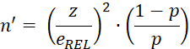
Where:

For a finite population, the sample fraction can be calculated as:
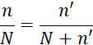

This yields several different Metering Fraction curves as a function of the two variables to be fixed,in addition to the population size (N) and the True Population Proportion (p) .
The following figure shows the resulting curve based on the ISO’s approved decision to set the Relative Precision Level to 10% and the Level of Confidence to 90%, which results in a z of 1.645 . Since the True Population Proportion is difficult to calculate, a value of p = 0.5 is chosen, similar to other ISOs and RTOs. The sample size for an infinite population with these requirements is therefore:
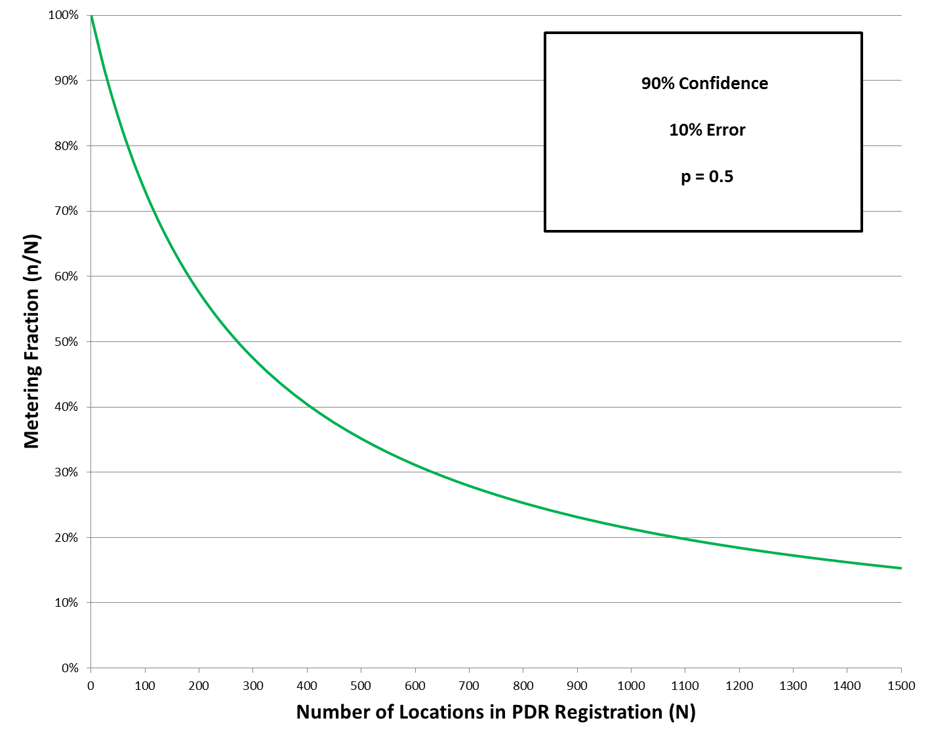

Minimum Sample Fractions

The ISO requires that every resource employing the approved statistical sampling methodology have a sample fraction:
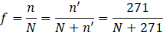

The following table shows a number values for the fraction based on the number of locations:

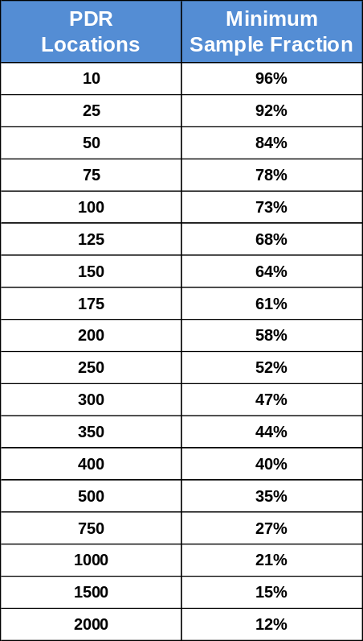

Resource Registration
PDR and RDRR Resource ID
The PDR and RDRR Resource ID is a CAISO assigned Resource ID that represents a Proxy Demand Resource or Reliability Demand Response Resource in the CAISO Markets. The Resource ID will be used to bid, schedule, receive an award, receive Automated Dispatches System (ADS) instructions and be settled in the CAISO Markets. There are certain steps that must be accomplished by the DRP, LSE, UDC, and CAISO before the CAISO can assign a PDR or RDRR Resource ID.
There are two different types of Resource IDs that can be assigned to a PDR or RDRR;
- Pre-defined – A pre-defined resource is one that has been pre-modeled within a SubLAP by the CAISO using pre-identified nodes and pre-established distribution factors.
- Custom - A custom resource is one that is, upon request of the DRP, specifically for resource that is not in the existing CAISO modeled within a SubLAP using customized DRP identified Pricing Node(s) within a SubLAP and customized distribution factors based on actual load curtailment across the Nodes.
Registration versus Resource ID Relationship
Both pre-defined and custom Resource IDs will have a 1:1 relationship with a current registration.

Generation Data Template Submission and Processing
Resource management requires interfacing with the Masterfile and Resource Modeling processes. Resource modeling sets up and maintains resource characteristics and scheduling coordinator assignments used in the market and systems to reliably operate the grid. Once the Registration is in the confirmed status, the DRP must follow this process and timelines associated with it to establish a PDR/RDRR in the Masterfile or to make updates to an existing PDR/RDRR attributes. The Masterfile maintains all resource attributes used in the markets and is the system of record for resource participation.
The Generator Resource Data Template (GRDT) is used to submit requests to add or change specific operating parameters that reside in the Master File. All GRDTs shall be sent to the RDT@caiso.com. Please see Business Practice Manual (BPM) for Market Instruments, Appendix B for Master File update procedures, and data elements in the GRDT. In addition to the BPM for Market Instruments, the GRDT and IRDT Definitions provides definitions of the data elements, business rules, and tips for making changes.

Custom Resource ID

After the SC has successfully create a registration in DRRS for the “Custom” Resource type, the SC shall submit the GRDT to RDT@caiso.com. The SC must provide the Registration ID in the “Comment” column, the Resource ID (blank) and the SC/DRP can determine any name for the Resource Name (RES_NAME). If Resource ID = Resource Name, leave the Resource Name blank.
The CAISO will notify the SC with the Resource ID and the effective date in Master File.
Registration Levels
The CAISO will provide the ability to allow changes to the underlying end use Load customers without having to issue a new Resource ID to the DRP. Registration levels were created to allow flexibility for the DRP to revise its end use customers associated with a PDR or RDRR, without having to request a new Resource ID. The registration level will also allow easier application of the baseline, as will be explained below. The key aspect of the registration level is that the meter data for both the baseline and the event day will need to be submitted to the CAISO at the registration level of the Resource ID.
The Demand Response Registration System allows the DRP to create registrations. These registrations must maintain the same standards as the overarching PDR or RDRR with underlying Load represented by the same LSE and located in the same Sub-LAP. Each registration must represent participation in the same market(s), and for a RDRR the registration must have the same real-time dispatch option (marginal or discrete) and seasonal term designation.
Since Registrations can be effective dated, changes to underlying locations can be staged to maintain sequential confirmed Registrations for a given Resource ID minimizing risk of participation gaps for the PDR/RDRR. This allows for ongoing changes to occur at the registration level with limited impact to the effective date of the PDR or RDRR in the Master File when Registrations are changing based on underlying Location effective date changes. It is the DRPs/SCs responsibility to monitor the Registrations in DRRS and ensure that changes are made to the Master File to accurately represent their PDR/RDRR market participation capabilities including the resources PMax, and effective dates.
The CAISO will take automated measures to identify and correct cases where there is an effective PDR/RDRR Resource ID in the Masterfile without a valid corresponding effective Registration in the DRRS. This correction may include:
- End-dating of the identified Resource ID
Any Master File update may take 5 to 11 business days to implement, depending on the complexity of the changes, and is subject to the Master File Data Freeze.
The Masterfile maintains the discrete dispatch selection for RDRR resources. The discrete dispatch status may be selected once during a Reliability Demand Response Services season (winter/summer). A season is a 6 month period (summer and winter). Once selected, the status shall be maintained throughout the season. The discrete dispatch flag may be selected once within a season such that after the initial season selection, selection updates can be made ONCE in subsequent seasons.
- Summer season runs from June through September
- Winter season runs from October through May
Additionally, for RDRR Masterfile set up the following requirements apply:
- Each RDRR must have a minimum of 500 kW of load reduction.
- Each RDRR may choose a Discrete Real-Time Dispatch Option once each season. Non-selection defaults RDRR to the Marginal Real-Time Dispatch Option which must remain until the end of the season.
- The maximum load curtailment for a resource that selects the Discrete Real-Time Dispatch Option shall be no larger than 50 MW. There is no maximum for RDRR selecting the Marginal Real-Time Dispatch Option.
- Each RDRR must reach its maximum load curtailment within forty (40) minutes after it receives a Dispatch Instruction, and must be capable of providing Demand Response Services for at least four (4) consecutive hours per Demand Response Event.
- Each RDRR must have a minimum run time of no more than one (1) hour.
- Bid Dispatchable Option is in 5 minutes only.
Starting ESDER 3A initiative with respect to Master File impacts:
- SC may elect to use the 60-minutes or 15-minutes bid dispatchable options for PDRs. All PDRs with no election will be defaulted to 5-minute. SIBR will utilize the value from Master File, and will not allow any changes in the application for PDRs. RDRR will only be set to 5-minute, please refer to the BPM for Market Instruments section B.2.1 for definitions and business rules. And for settlements’ treatment, please refer to the BPM for Settlements and Billing.
- With the removal of a single Load Serving Entity (LSE) requirement and Default Load Adjustment (DLA) application, Master File will store a new Demand Response (DR) Type attribute, “DR_TYPE”, which is an identifier denoting the Demand Response Resource -- “PDR” or “RDRR”. This field will be set in the Master File based on the valid registration in the Demand Response Registration System. SCs will be able to view this attribute on the GRDT, but not modify.

Net Qualifying Capacity (NQC) values for Resource Adequacy (RA)
Resources with RA capacity must establish net qualifying capacity values (NQC) prior to submitting a Resource Adequacy (RA) Plan or a Supply Plan. To do so, the SC must submit an NQC request form through the CIRA application. The NQC request form is available on the CAISO website at: http://www.caiso.com/planning/Pages/ReliabilityRequirements/Default.aspx.
Please see the BPM for Reliability Requirements for more details on NQC and RA, as well as the timeline the SC must follow for NQC, RA Plan and Supply Plan submission.

Telemetry
Telemetry is a requirement of market participation for a PDR with a rated capacity (Pmax) greater than or equal to 10 MW. It is also required for a PDR that requests certification to provide non-spinning and spinning reserve at any rated capacity (Pmax). Please refer to the BPM for Direct Telemetry for details on the ISO direct telemetry process, diagram, and validation process of telemetry data flow.
DR seeking Telemetry may follow the flowchart, and checklist posted on the CAISO website under the “Demand response and load” section at: http://www.caiso.com/participate/Pages/Load/Default.aspx
Telemetry request shall follow the Full Network Model schedule.

Using the Appropriate Systems for Meter Data Management, and Performance Data Submittal
Scheduling Coordinators must submit Demand Response Energy Measurement (DREM), and monitoring data (as applicable) into the Market Results Interface-Settlements system (MRI-S). DREM submissions will be considered Settlement Quality Meter Data (SQMD). DREM represents performance of the resources in response to a schedule or dispatch and will be used for the market settlement calculation. Additionally, Proxy Demand Response Resources providing Ancillary Services must submit Load Meter Data into the MRI-S for the interval preceding, during, and following the Trading Interval(s) in which they were awarded Ancillary Services. The data requirements for submittal into MRI-S for each Baseline/Performance Evaluation Methodology are listed in Appendix B.
For more information regarding Meter Data management and timelines, please refer to the Business Practice Manual (BPM) for Metering section 12.7.

Using Customer Market Results Interface (CMRI)
For PDR selecting the 60-Minute, and 15-Minute bid dispatchable options, utilize CMRI to obtain dispatch instruction, until the ADS Replacement Project is implemented. Scheduling coordinator may also obtain the report in CMRI to view Event or Total Expected Energy (TEE).
The three (3) reports are listed below:
- Expected Energy report to view whether there is an Event or TEE.
- Real-Time Unit Commitment (RTUC) Advisory Schedules (60-Minute)
  - The report is published as Advisory, but should be considered binding for PDRs selecting the hourly bid option.
- Fifteen-Minute Market (FMM) Schedules (15-Minute)
For more information on how to pull the reports, see the Demand Response User Guide available at www.caiso.com

DRRS Monitoring Process
The CAISO will monitor through the demand response applications and business processes the performance of the PDR or RDRR. In general, the CAISO will look at certain metrics across all PDR and RDRR and will flag those which fall outside typical ranges. However, based on monitoring results, the CAISO will take action pursuant to CAISO Tariff Section 30.6.3.

Outages
A PDR or RDRR is allowed to have outages but will be limited to updates to its ramp rates or to modifying its capacity to 0. PDR and RDRR are all-or-nothing resources, which limits how much such resources can be derated. PDR and RDRR are also prevented from submitting a rerated of their PMin. OMS has been updated to enforce these business rules.
OMS has been updated to permit a PDR or RDRR to submit only PMax derates or Ramp Rate derates. Any other data entered in OMS through either the UI or API for a PDR or RDRR Resource ID shall return an error message. It also has validation to restrict PMax derates entries for PDR and RDRR Resource IDs to be only 0 MW. A PMax derate is used to indicate a day should not be used in the baseline calculation. Since a day is either valid or invalid, no partial derates are permitted. Any PMax value other than 0 MW entered in OMS through either the UI or API for a PDR or RDRR Resource ID shall return an error message.
Cause codes are no longer required when submitting outages.
In order to keep a Resource ID active and reduce the need to make updates to the CAISO Master File, the DRP using its scheduling coordinator can submit extended outages to derate its resource to 0 MW when it does not wish to participate in the market. Please see Operating Procedure 3220 for more information.

Net Benefits Test (NBT)
ISO Tariff section 30.6.3
The Net Benefits Test will establish a Market Clearing Price for PDRs and RDRRs. PDR or RDRR bids for energy will be required to be at or above the Market Clearing Price in the CAISO market.
The CAISO will post on the CAISO website the Net benefits Test’s Market Clearing Prices that in effect in the previous 12 months, and any update to the supply curve analysis. The monthly future gas prices are used in the calculation of Demand Response NBT threshold prices, please see Appendix C of BPM for Market Instruments.
The process for determining the Market Clearing Price is set forth in Section 30.6.3.1 of the CAISO tariff.

Appendix A: Definitions
The following defined terms and acronyms are used throughout this document:

Terms | Definition
ADS | Automated Dispatch System
AIM | Access Identity Management (AIM) application. The application provides registered UAAs with the ability to view application-level access for all of their organization’s users as well as any users from other organizations who have access to their resources (endorsed users).
AIMS | Access and Identity Management System – application used to provision access to users of the DRRS
API | Application User Interface. Allows users to upload bulk location data to accommodate the input of the volume of locations participating in the Demand Response Program.
CLB | Customer Load Baseline
CMRI | Customer Market Results Interface
Custom Resource ID | A unique resource ID requested by the DRP, modeled with their specified nodal locations and associated generation distribution factors (GDF).
Customer | The name of the customer that user assigned during the registration process.
Demand Response Energy Measurement | The quantity of Energy equal to the difference between (i) the Customer Baseline for the Proxy Demand Resource or Reliability Demand Response Resource and (ii) either the actual underlying Load or the quantity of Energy calculated pursuant to Section 10.1.7 for the Proxy Demand Resource or Reliability Demand Response Resource for a Demand Response Event.
DRP | Demand Response Provider
DRP SC | Demand Response Provider Scheduling Coordinator who are responsible for submitting bids into the market and meter data to the MRI-S.
DRPA | Demand Response Provider Agreement previously called Proxy Demand Resource Agreement (PDRA).
DRRS | Demand Response Registration System. Allows users to create large volumes of locations and aggregate locations for participation in the ISO’s demand response program.
DRRS UI | Demand Response Registration System User Interface
Event | Total Expected Energy (TEE) > 0
FMM | Fifteen-Minute Market
HASP | Hour-Ahead Scheduling Process
Load Reduction | The total Load Reduction capacity per location
Location name | Identifies the location/site for the user
Locations | Physical location of the demand response entity. This includes the customer data such as the service account number, physical service location, and curtailable load amounts.
LSE | Load Serving Entity
MF | Master file database contains the physical characteristics and data used by the CAISO for
MSA | Meter Service Agreement
NBT | Net Benefit Test
New Custom PDR | CAISO will develop a new resource ID for this registration (custom).
PDR | Proxy Demand Resource
PEM | Performance Evaluation Methodology or also known as Baseline Methodology. A baseline is an estimate of the expected consumption had there not been a demand response event.
Pnode | Pricing Node - A single network Node or subset of network Nodes where a physical injection or withdrawal is modeled and for which a Locational Marginal Price is calculated and used for financial settlements.
Pre-Defined Resource ID | A pre-established resource ID pre-modeled in each SubLAP based on CAISO specifications and available in the MasterFile for DRP to request assignment to a registration.
RDRR | Reliability Demand Response Resource
Registration | Comprised of a single location or an aggregation of many locations. Submitted by the DRP to the LSE and UDC for review and CAISO for approval. Meter data is also submitted at the registration level for the baseline calculation prior to the market participation.
Resource ID | A unique ID used for participation in the ISO wholesale markets (scheduling/bidding and settlements). Assigned by the CAISO during the registration process in the Demand Response Registration System. Resource specific information for the ID resides in the ISO Master File.
RUC | Residential Unit Commitment
SQMD | Settlement Quality Meter Data
SubLAP | Sub-Load Aggregation Point, which represents an aggregation of PNodes within a Default Load Aggregation Point (DLAP). There are 23 SubLAP locations in CAISO. The SubLAP is the location in which all the locations within the registration reside.
UAA | User Access Administrator
UDC | Utility Distribution Company. The UDC is the entity that operates an electric distribution system. It is also where the Locations in the Registration reside and is an entity that is a part of the approval process.

Appendix B: Baseline/Performance Evaluation Methodology Data Submittal Requirements

Baseline Methods and Measurement Type mapping:
Measurement Type | Data Granularity | Baseline Method | Comments
LOAD | 5 minute | - Control Group  - Day Matching 5/10 (Residential Only)  - Day Matching 10/10  - Day Matching Combined  - Weather Matching  - Meter Generation Output  - Meter Generation Output with 10 in 10 | AS Resource only  This is the actual load for intervals the resource receives an Ancillary Service award.  Both LOAD and MBMA data sets are required for no pay calculations, even though the LOAD data includes the same values submitted in the MBMA data set.
GEN | 5 minute | - Control Group  - Day Matching 5/10 (Residential Only)  - Day Matching 10/10  - Day Matching Combined  - Weather Matching  - Meter Generation Output  - Meter Generation Output with 10 in 10 | Demand Response Energy Measurement (DREM) or performance data of the resource in response to an award or dispatch. Data required for intervals where TEE>0.
MBMA | 5 minute | - Control Group  - Day Matching 5/10 (Residential Only)  - Day Matching 10/10  - Day Matching Combined  - Weather Matching  - Meter Generation Output  - Meter Generation Output with 10 in 10 | AS Resource Only  This is the actual load data for the interval preceding, during, and following the trading intervals for which they were awarded ancillary services.
CBL | Hourly | - Control Group  - Day Matching 5/10 (Residential Only)  - Day Matching 10/10  - Day Matching Combined  - Weather Matching  - Meter Generation Output with 10 in 10 | For monitoring only.  Underlying load data used in the customer load baseline calculation for all baseline methods. 90 days of historic data prior to the day of the event is required.  This is applicable for the “MGO with 10 in 10” only. It represents the net load data used to develop the customer load baseline of the facility only. 90 days of historic data prior to the day of the event is required.
TMNT | Hourly | - Control Group  - Meter Generation Output  - Meter Generation Output with 10 in 10 | For monitoring Only  90 days of historical data prior to the day of the event is required.  For the Control Group baseline method, data represents the actual load data for those locations in the treatment group.  For the MGO and MGO 10 in 10 baseline methods, TMNT data represents the generation device metered values.
BASE | Hourly | - Control Group  - Day Matching 5/10 (Residential Only)  - Day Matching 10/10  - Day Matching Combined  - Weather Matching  - Meter Generation Output with 10 in 10 | For monitoring Only  Calculated customer load baseline (CLB) values used to derive DREM.  For the “MGO with 10 in 10”: BASE data represents the customer load baseline used to calculate the DREM attributed to the pure load reduction only.  BASE data is submitted for trade dates when the resource/registration is being actively bid into the market for the hours in which it is bid.

- GEN: This represents the resources DREM
- CBL: This represents the Load data during the event
- TMNT: For Control Group, this represents the actual underlying consumption or energy of the Loads participating in the resource. For Metered Generation Output (MGO), and Metered Generation Output (MGO) with 10-in-10this represents the generation device metered.
- MBMA: This represents Load data for PDR resources providing Ancillary Services. The Scheduling Coordinator must submit Meter Data for the interval preceding, during and following the Trading Interval(s) in which they were awarded.
- BASE: This represents the customer load baseline (CLB) used to calculate the DREM attributed to the pure load reduction only.
“BASE” measurement type must be submitted in hourly interval granularity for the trade dates when the resource is actively bid into the market for the hours in which it bid. The SC shall calculate and submit adjusted baselines for the hour that the resources is bid into the market, and received an award, in this case, the hourly interval Total Expected Energy (TEE) is greater than 0. If the resource is bid into the market, and received an award, the SC shall calculate and submit adjusted baselines, and submit unadjusted baselines for other hours.

Example of “BASE” measurement type and when to apply and not to apply adjustment baseline.
Resource A is bidding in the day-ahead market for hour ending 14 through 21, and in the real-time market for hour ending 17 through 22. The resource received an award for hour ending 18 and 19. The SC will need to submit adjusted baseline for hour ending 18 and 19, and unadjusted baseline for the other hours ending 14-17, and 20-22.

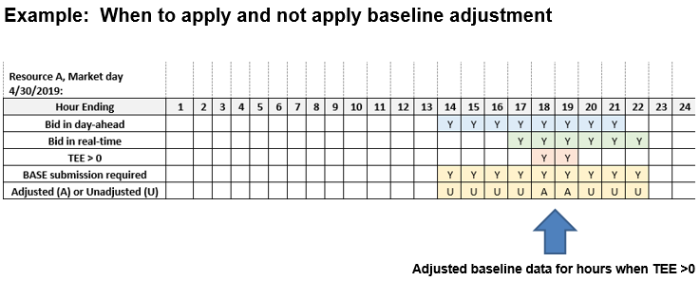

To ensure accuracy and compliance with the CAISO tariff, the CAISO will have the right to audit Meter Data submitted by SCs to establish performance evaluation methodologies or Demand Response Energy Measurements.

Timeline is an estimation only and is subject to change upon completion of scheduled process enhancements designed to gain efficiencies and reduce timelines associated with the registration resource management process.
G_{Load Modifying} or G_{LM} is an ISO term used to represent an estimated value of the typical retail load modifying behavior of the behind the meter generating device.
Holidays = FERC holiday minus Presidents’ Day, Veterans Day and Columbus Day
In compliance with the direction provided in FERC Order No. 745, the ISO posts the price thresholds and supply curves that would have been in effect for the previous 12 months, as well as the threshold price and supply curve for the next trade month by the 15th day of the current month.
Generally referred to as the combined CLB and MGO Methodology.
The gross load meter data reflects the load consumption at that location independent of any offsetting Energy produced by behind-the-meter generation.
Attachment A provides DRPs with a template that can be submitted to the CAISO to request use of the approved Statistical Sampling Methodology. The CAISO requires 10 business days to process requests submitted with completed template provided.
The value of z is derived from a distribution of samples with 10% of the high samples and 10% of the low samples in the two respective tails of a Gaussian distribution.
Detailed information on the CAISO Resource Modeling process can be found at http://www.caiso.com/market/Pages/NetworkandResourceModeling/Default.aspx
GRDT definition and business rules for DR_TYPE: PDR is Proxy Demand Response, RDRR – Reliability Demand Response Resource, and all others are Null.
Expected Energy report is used by all PDRs, irrespective of selecting the 60 minute or 15 minute bid dispatchable options.
“MGO” is a performance evaluation methodology that can be used by a generation device located behind the revenue meter, to represent the load reduction attributed only to the output of that generation device excluding its typical use. Referred to as “generation offset only”.
“MGO with 10 in 10” under this performance methodology option, the demand response performance is a result of combining the demand response energy measurement (DREM) from pure load reduction calculated utilizing a customer load baseline (10 in 10, 5 in 10, weather matching) combined with the DREM from load reduction attributed to generation offset (MGO). Referred to as “load and generation”
For a Proxy Demand Resource or Reliability Demand Response Resource using behind-the-meter generation to offset demand utilizing one of the MGO performance methodology options, meter data submitted for LOAD and MBMA represents metered load for the service account (customer) not of the sub-metered behind-the-meter generator.
California Independent System Operator Corporation Tariff Section 4.13.4
“MGO with 10 in 10” provides for the use of 10 in 10, 5 in 10 (residential customers only) and weather matching performance evaluation methods in the calculation of the DREM portion attributed to customer load response only.

